# Angular

**Materials and resources:**

<https://angular.io/docs>

<https://cli.angular.io/>

<https://www.dunebook.com/from-zero-to-hero-learn-angularstrap-from-scratch/>

<http://www.netinstructions.com/100-days-of-angular-2/?utm_source=mybridge&utm_medium=web&utm_campaign=read_more>

<https://github.com/johnpapa/angular-styleguide/blob/master/a2/README.md>

<https://legacy.gitbook.com/book/basarat/typescript/details>

<https://basarat.gitbooks.io/typescript/>

<https://www.youtube.com/watch?v=qRD7bkK7m10>

<https://thinkster.io/tutorials/learn-angular-2>

<https://www.tutorialspoint.com/angular2/>

Books: ng-book2-r37

**Assignments:**

Task 1: Add Product

* When user select ‘Add new’ button following page is open.
* All fields with * sign are required fields
* On click on a ‘Save’ button category is saved and the user is redirected to ‘Product list page’
* On click on a ‘Cancel’ button, the user is redirected to Product list page’

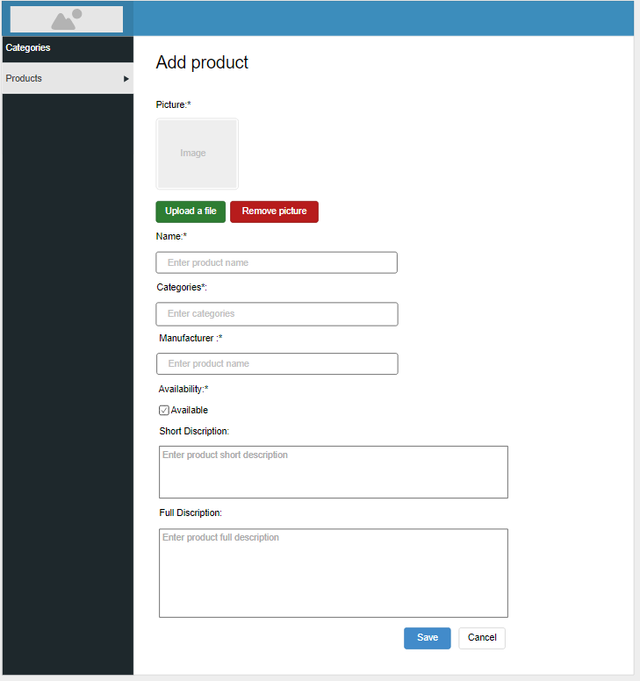

Admin: Product add page

Task 2: Edit Product

When a user clicks on ‘Edit’ button on some item from ‘Product list page’ is redirected on ‘Product edit page’. All fields are prepopulated with the product data. The user can change the data and on click on ‘Save’ button, changes are saved and the user is redirected on ‘Category list page’. On click on ‘Cancel’ button, changes are not saved, the user is redirected on ‘Category list page’.

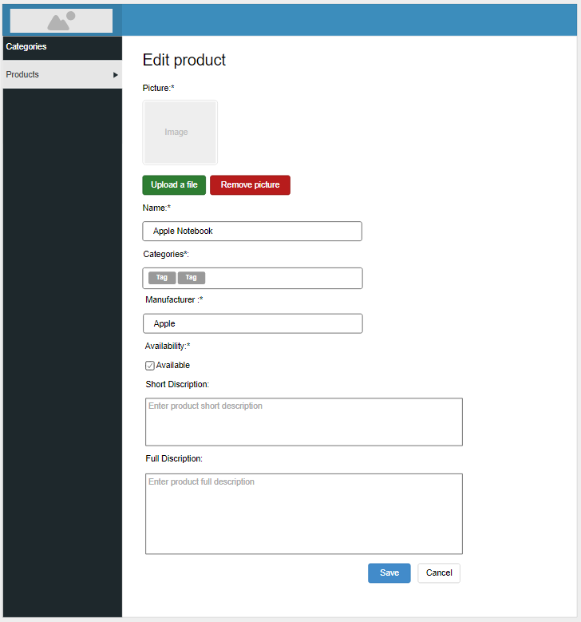

Admin: Product edit page